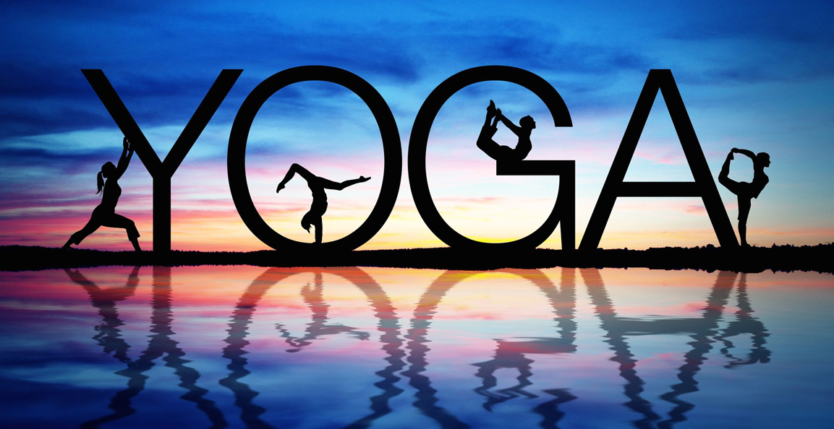
Yoga at Palo Verde High School
Instructor: Mrs. Duong Room: 308
Email: mhduong@interact.ccsd.net
Remind: Via text to: 81010 Message: @paloyoga
Website: http://duongsartroom.weebly.com

Dear Parent/Guardian:

Palo Verde is offering students a chance to participate in yoga practice from 2:30-3:30 in room 308. Man Hue Duong, a certified yoga instructor who has been teaching yoga for the past 8 years and teaching art for over 16 years, will lead the practice. Our first practice will be on Thursday, September 24. More dates will be available and will be posted on Mrs. Duong’s website, http://duongsartroom.weebly.com under Palo Yoga for your reference.

During the practice, students will be led through basic breathing techniques, yoga postures, and relaxation. The skills are designed to help our students learn to increase strength, self-confidence and focus through an awareness of mind and body. During yoga practice students should wear comfortable clothes they can move around in. Students will need a yoga mat (some will be available if they do not have their own) and water when practicing.

Please complete the permission slip below and have your child return it to
Mrs. Duong. Space is limited. Please return permission slips as soon as possible. If you have any questions please feel free to contact Mrs. Duong at the contact information above.

Man Hue Duong

Art Specialist
Yoga Instructor RYT 200 hr.

_______________________________________________________________________
Yoga Permission

I give permission for my child, ______________________________________________
to attend yoga practice at Palo Verde High School. I understand that undertaking any physical activity has some inherent risks and I agree to not hold PVHS liable for any injury my child might sustain related to performing yoga before, during or after the sessions.

Signature of Parent/Guardian________________________________________________

Phone number in case of an emergency _______________________________________

Date_________________________

