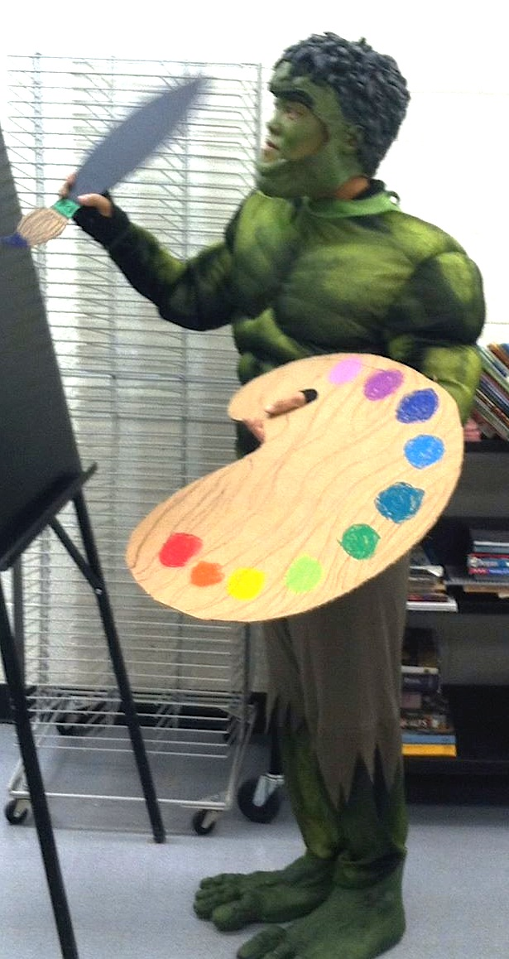
Art 1 Syllabus

Instructor: Mrs. Duong Room: 308
Email: mhduong@interact.ccsd.net
Remind: Via text to: 81010 Message: @mrsduon
Via email send to: mrsduon@mail.remind.com Message: Blank
Website: http://duongsartroom.weebly.com

Class Fee: There is a $40 fee for Art 1which covers the cost of student’s supplies for the year. This needs to be paid as by ___________. Payment can be made in cash or money order to Mrs. Duong or online at Palo Verde’s Web Store at http://www.paloverde.org (click on Web Store). ***Personal checks are no longer accepted.***
**Duong Hulk Painting**
Course Description: Art 1 is an introduction to art through a multi-media experience. Students will learn and apply the elements and principles of design to produce unique art that reflects these concepts. Art 1 is a year long class and fulfills and arts/humanities credit required for graduation.
Visual Art Standards:
CREATE: Art production and application of learned concepts to create unique, challenging & meaningful work.
PRESENT: Sharing artistic work & responding to the work of others.
RESPOND: Understanding & evaluating the meaning of art through criticism & discussion of concepts and art history knowledge.
CONNECT: Relating artistic ideas & work with personal meaning & external content. Understanding artistic meanings, choices artist made & history to apply to past & current art work.
Basic Rundown: You will be doing weekly projects and skill building activities that will develop your artistic skills. You will also be responsible for learning art specific vocabulary, artist from various time periods throughout history, preliminary thumbnails sketches of possible resolutions to projects, responding to your own artwork and others, homework that supports work we are doing in class and quizzes and tests. You are given ample class time, so quality work is expected. Everything I give you has a purpose & will be graded.
Be Successful: You are expected to be on time & have your class supplies with you every day. Work hard & use your time wisely! Be responsible and honest, you are accountable for your actions. Please be respectful and use appropriate language. Please use art tools safely and properly. You are also expected to clean up after yourself every day.
Class Consequences: 1. Verbal or non-verbal warning. 2. Documentation from teacher 3. Student/teacher conference about behavior. 4. Parent notification & Administrative intervention. *Serious offenses will be dealt with on a case by case basis and can include in or out of school suspension.
Absences: Students are expected to attend all classes. Students are responsible for any missed work due to excused absence and have 3 days from the day of return to submit missed work. After seven missed classes a denial of credit will be issued.
Tardiness: You are expected to be on time every day and begin working as soon as class starts. If you are late, you must sign in, drop off a pass if you have one, and begin working immediately. Being tardy is not going to be tolerated and will be dealt with until the problem is solved.
Grades: Quarter Grades: Projects 50%, Classwork 30%, Homework 20 % Semester Grades: Quarter 1 45% Quarter 2 45% Midterm 10% (same for semester two)
Materials: You are required to have a 9X12 100 pages (+) sketchbook, Pocket folder, pencils and erasers. If you would like to purchase your own art supplies as projects start, you are welcome to do that too. Supplies are due by________. If you would like to make any contributions to the art room I am more than happy to accept them!

